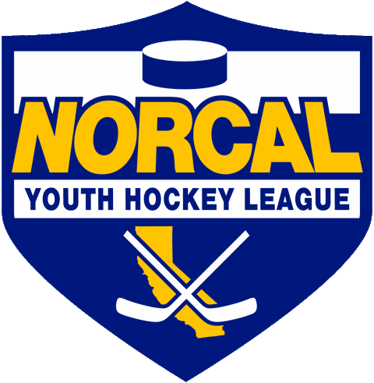
Northern California Junior Hockey Association Board Meeting
August 17th, 2020 @ 7:00pm –Via ZOOM
Meeting called to order @ 7”06pm by Dan Granata. Quorum was determined.
Introductions made.
Approval of November Minutes- Meeting minutes approved by Chris Hathaway, second by Aly Bailey.
ATTENDANCE:
Name | Club or Roll | In Attendance
Dan Granata/PRESIDENT | NORCAL President | X
Laura Cahn | NORCAL General Manager | X
Suzanne Spradling | NORCAL Vice President | X
Dana Olenak | NORCAL Secretary | X
Robert Grande | NORCAL Treasurer | X
Tyler Shaffar | NORCAL Scheduler | X
Chris Hathaway | NORCAL Member-at-Large | X
Chip Cormier | NORCAL Goalie Development
Teresa Attebery | PACIFIC DISTRICT/ Roster Manager | X
Darren Attebery | NORCAL Mite Coordinator | X
Andy Dickerson | NORCAL Webmaster
Mark Mauro | NORCAL Referee-in-Chief | X
 | NORCAL SafeSport
Mike Janda | NORCAL Director of Coaches
Todd Llewellyn | IHONC President | X
Chris Hathaway | Cupertino - President | X
Darren Redmond/Suzanne Spradling | Fresno – President
Alison Bailey/Hannah Hannon | Black Stars -President | X
Chi Tse | Oakland Club President | X
Jason Stiles | Roseville Capital Thunder - President | X
Chris Clima | Santa Clara – President | X
Robert Savoie/Shane Galaviz | San Jose - President / Proxy | X
Anne Woida/Chris Petrus | Santa Rosa Club President | X
Blaine Machart | Stockton –President | X
Ken Wood /Leticia Dries | Tahoe Grizzlies -President | X
Cameron Higley | Tri-Valley - President | X
George Caliando/Mark | San Francisco - President | X
Larry Cahn | Vacaville Jets-President
OTHERS IN ATTENDANCE
William Stone – Tri Valley
Scott Roberts-Santa Clara
Nik B..-San Jose
Tom Hancock-CAHA

PRESIDENT –Dan Granata

- CURRENT STATE OF AFFAIRS:
  - Not a lot of direction. AS an organization we need to protect our kids/clubs.
- CAHA Rosters (Out of state Play)
  - Do we allow our A/B/BB players to play outside USA Hockey sanctioned tournaments?
  - SCAHA has voted “NO” not to allow this. They will not be playing until the state has opened up play.
  - Per Tom Hancock- Tier l & ll are allowed to play . Approval process will look at other teams wanting to be allowed to play AA They will be denied if they are not a true Tier team(meaning falsely declared with lower level players).
  - Will be an application process to try to go out of state. Must meet ability to play at that level to go, if not, no go.
  - Will look at where players (and what level) played prior season.
- NORCAL’s Position on Rosters:
  - Discussion took place on whether or not to allow out of state travel/play for our teams. Talked with each club president for opinions.
  - CAHA oversees Tier l & ll and does allow travel out of state. If a club decides not to allow their Tier team(s) to travel, CAHA will follow the club’s request for that club.
  - Per Tom, CAHA decided to allow travel play at this level because the majority of Tier l games are played out of state every year. They are also part of other leagues, etc…and some of those leagues have returned to play.
  - San Jose is not allowing travel until ok’d by county.
  - Motion made to not approving rosters for out of state travel tournaments prior to October tryouts for A/B/BB by Blain Muchart, second by Chris Petrus. Motion approved. (Season “officially” starts 9/1, so all prior rules are in effect as of that date).
  - Dan/Suzann to generate memo and pass out to clubs/coaches.
- H/S Hockey-In a holding pattern. Next meeting will dig into the 18U division change and how to handle 1st year. No new developments. TABLED

GM UPDATES-Laura Cahn- NO REPORT

FINANCIALS/Robert Grande-NO REPORT

REGISTRAR UPDATES- Teresa Attebery-
- Mock declarations/Teresa/Dan to create new google doc for team declarations.
- USA Hockey language that will be printed on all team rosters has been sent to clubs.
- USA Hockey will be meeting with registrars groups periodically. Will forward any new/upcoming information.
- USA Hockey working on gathering info on the status of hockey in their districts/states.

IHONC-Todd Llewellyn-
- Status of New Referee Certification & Recertification
- Postponing seminars until closer start of the season. Currently set to begin early September. Registration is open now.

MITE JAMBOREE-Darren Attebery-NO REPORTS

OLD BUSINESS

- Contact Listing-Contact listing has been updated.
- https://docs.google.com/spreadsheets/d/1U8XJjSXTRc-L9xJRwGzxs40RpLhx70rhnSridDXY1P0/edit?usp=sharing

NEW BUSINESS
- Add/Drop dates TBD per tryout dates.

DISCUSSIONS

Closing
Meeting adjourned @ 8:34pm. Motioned by Robert Grande, second by Chris Hathaway.
Next meeting: September 22nd, 2020 7”00pm via zoom.

