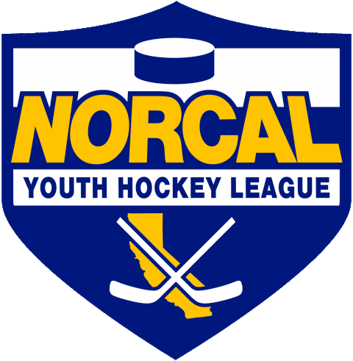
Northern California Junior Hockey Association Board Meeting
July 18th, 2020 @ 10:00am –Via ZOOM
Meeting called to order @ 10:01am by Dan Granata. Quorum was determined.
Introductions made.
Approval of November Minutes- Meeting minutes approved by Jason Stiles, second by Chi Tse, with corrections.
ATTENDANCE:
Name | Club or Roll | In Attendance
Dan Granata/PRESIDENT | NORCAL President | X
Laura Cahn | NORCAL General Manager
Suzanne Spradling | NORCAL Vice President | X
Dana Olenak | NORCAL Secretary | X
Robert Grande | NORCAL Treasurer | X
Tyler Shaffar | NORCAL Scheduler | X
Chris Hathaway | NORCAL Member-at-Large | X
Chip Cormier | NORCAL Goalie Development
Teresa Attebery | PACIFIC DISTRICT/ Roster Manager | X
Darren Attebery | NORCAL Mite Coordinator | X
Andy Dickerson | NORCAL Webmaster
Mark Mauro | NORCAL Referee-in-Chief | X
 | NORCAL SafeSport
Mike Janda | NORCAL Director of Coaches
Todd Llewellyn | IHONC President | X
Chris Hathaway | Cupertino - President | X
Darren Redmond/Suzanne Spradling | Fresno – President | X
Alison Bailey/Hannah Hannon | Black Stars -President | X
Chi Tse | Oakland Club President | X
Jason Stiles | Roseville Capital Thunder - President | X
Chris Clima | Santa Clara – President | X
Robert Savoie | San Jose - President / Proxy
Anne Woida/Chris Petrus | Santa Rosa Club President | X
Blaine Machart | Stockton –President
Ken Wood /Leticia Dries | Tahoe Grizzlies -President | X
Cameron Higley | Tri-Valley - President | X
George Caliando/Mark | San Francisco - President | X
Larry Cahn | Vacaville Jets-President
OTHERS IN ATTENDANCE
William Stone – Tri Valley
Stacy Gray
Tom Hancock-CAHA

PRESIDENT –Dan Granata

- Tryout Dates: Were approved at a special CAHA meeting on Saturday, pending the state approves a return to play protocol for team play.
  - Review the attached CAHA letter.
  - No rosters will be approved for teams or tournament play until state ok’s play.
  - Currently no drop dead date has been set to where we will not move forward with this season.
  - Our goal is to play some sort of season, whatever it takes. If we are able to get in some games, then have to pause, we will continue when we can.
  - Hockey falls into “Stage 4” currently for any organized play. Tryouts and skills/drills are allowed to take place during “Stage 3”.
  - CA need’s to further address youth sports. We are on hold until they do.
  - When they do approve/open some counties, we will evaluate at that time to determine equity/fairness. Some counties may keep rinks closed. We will look at all options like rink sharing/good neighboring for practices/games.
  - If Nationals are not canceled, and everything improves/goes as planned for Tier l, they can go to Nationals.
  - CAHA would be open to making allowances this season regarding the minimum number of players on teams this year. Would also be flexible on national bound teams.
  - NORCAL to draft a proposal for clubs to be submitted to counties outlining conditions we would follow to be able to return to play. Such as, no spectators, temp taken at door, team COVID testing, no checking, outside dress only, etc. Once proposal is finalized NORCAL will help facilitate submission to counties.
  - Roseville rink will be leaning towards checking temps of all before entering the Roseville facility. Suggestion made to make this standard practice for all NORCAL rinks.
  - Per Tom Hancock: “Not sure we would need to do anything above the states stage 4 guidelines when the state permits a return to play..
  - Comp Committee will perform as usual once we can return to play with relegation TBD.
  - Playoffs will be discussed at next meeting.
  - Suggestion made that if a player or coach tests positive with COVID, we need to require notification to the team(s) they just played prior to positive test. Details will need to be worked out because of HIPPA.

- Review AA:
  - Top 2 NORCAL and top 4 SCAHA AA teams will go to states.
  - No playdowns.
  - NORCAL and SCAHA AA will schedule their own games.
  - CAHA has approved overnight travel for X games for Tier ll.

- Director of Coaches: We are in search of a Director of Coaches. If you have someone in mind, or know of someone who would be interested, please contact Dan Granata/Chris Hathaway. Need to have hockey experience and the ability to run Selects.
- Rink Status: Santa Rosa remains closed per Chris Petrus. Does not foresee any information from Sonoma County before sometime in mid-August.
- H/S Hockey-In a holding pattern. Next meeting will dig into the 18U division change and how to handle 1st year. No new developments.

GM UPDATES-Laura Cahn-
- Managers Meeting
  - TDB, will be scheduled when season is able to begin. Will be by ZOOM, and recorded/posted on website for future viewing.

FINANCIALS/Robert Grande-
- Financials Team fees will adjust accordingly when the season starts. Budget is as of August. The same follows with stipends and board meeting fees.
- Budget have been sent out to clubs. Possibility of changing-TBD. Will finalize when we have more information on a season. ZOOM acct added into budget. Bank Acct in good shape.
- Scholarships are the same as last year per Robert.
- Motion made by Chi Tse second by Jason Stiles to approve said budget. Motion passed.

REGISTRAR UPDATES- Teresa Attebery-
- There are new portals for registrars.
- Please note: states rosters may not be approved or tournaments sanctioned until state approves return to play.
- Managers meeting/Registrars Meeting will proceed TBD when return to play is approved.
- Diversion inclusions information sent out to all. Has also been posted on the NORCAL Facebook page.

IHONC-Todd Llewellyn-
- Status of New Referee Certification & Recertification
- Ref seminars officially announced.
- Are posted on NORCAL site and have been sent to clubs.
- Seminars will take place via ZOOM. Tine has been cut down.
- Badly in need of new referees.
- Anticipating a number of non-returning ref’s due to COVID status.
- IHONC offering a finders fee of $100 (paid after 25 games of refereeing) for referrals.
- Chris/Todd: We need to work together to not loose referee’s due to coaches “banter”. Needs to be communicated to Todd/Laura if this is continuing to happen so they may report to clubs and address with coaches/club/parents.
- USA Hockey to supply Todd with some documentation with the “Zero Tolerance Rule.”

MITE JAMBOREE-Darren Attebery-
- No updates.

OLD BUSINESS

- CAHA sent out letter outlining tryout dates and process.

- Contact Listing-Contact listing has been updated.
- https://docs.google.com/spreadsheets/d/1U8XJjSXTRc-L9xJRwGzxs40RpLhx70rhnSridDXY1P0/edit?usp=sharing

NEW BUSINESS
- Per William Stone: Renewed the NORCAL.org domain as of 7/20/20.
- Add/Drop dates TBD per tryout dates.

DISCUSSIONS

Closing
Meeting adjourned @ 8:34pm. Motioned by Robert Grande, second by Chris Hathaway.

- Next Meeting Dates:
  - CAHA Special Meeting to be held approx. July 30th
  - NORCAL Board meeting August 17th, via ZOOM, @ 7:00pm.
  - September TBD
  - October TBD

