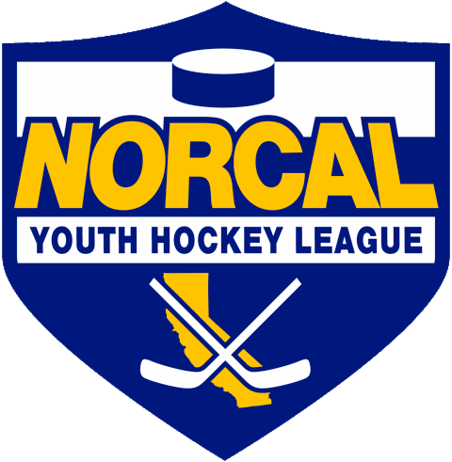
Northern California Junior Hockey Association Board Meeting
MAY 9th^{th}, 2020 @ 10:00am –Via ZOOM
Meeting called to order @ 10:04am by Matt Adams. Quorum was determined.
Introductions made.
Approval of November Minutes- Meeting minutes approved by Cameron Higley, second by Darren Redmond.
ATTENDANCE:
Name | Club or Roll | In Attendance
Matt Adams/PRESIDENT | NORCAL President | X
Laura Cahn | NORCAL General Manager | X
Dan Granata/PRESIDENT ELECT | NORCAL Vice President | X
Dana Olenak | NORCAL Secretary | X
Robert Grande | NORCAL Treasurer | X
Tyler Shaffar | NORCAL Scheduler | X
Chris Hathaway | NORCAL Member-at-Large | X
Chip Cormier | NORCAL Goalie Development
Teresa Attebery | PACIFIC DISTRICT/ Roster Manager | X
Darren Attebery | NORCAL Mite Coordinator | X
Andy Dickerson | NORCAL Webmaster
Mark Mauro | NORCAL Referee-in-Chief | X
 | NORCAL SafeSport
Mike Janda | NORCAL Director of Coaches
Todd Llewellyn | IHONC President | X
Chris Hathaway | Cupertino - President | X
Darren Redmond/Suzanne | Fresno – President | X
Alison Bailey/Hannah Hannon | Black Stars -President | X
Chi Tse | Oakland Club President | X
Jason Stiles | Roseville Capital Thunder - President | X
Chris Clima | Santa Clara – President | X
Shane Galaviz | San Jose - President / Proxy
Anne Woida/Chris Petrus | Santa Rosa Club President | X
Blaine Machart | Stockton –President | X
Ken Wood /Leticia | Tahoe Grizzlies -President | X
Cameron Higley | Tri-Valley - President | X
George Caliando/Mark | San Francisco - President | X
Dana Olenak Proxy | Vacaville Jets-President | X
OTHERS IN ATTENDANCE

PRESIDENT –Matt Adams
- Decision made not to hold playoffs. Focusing looking forward to opening for next season. Motion made to cancel playoffs by Chris Petrus, second by Chi Tse. Motion passed.

- Postponement of tryouts from CAHA until after the JUNE CAHA Board meeting.

- End of Season
  - Discussion on ending official ending of season took place. How do we want to recognize teams for the season? Motion made by Chi Tse to recognize 1st place teams in regular season/division, second by Blaine Muchart. Motion passed.

- Awards have been made by Robert Grande/Champion Sports. Will look into remaking what we can (1st/2nd) for next season.

- Elections took place for: President, Treasurer and Member at Large.
- Results: NORCAL President: Dan Granata
- NORCAL Treasurer: Robert Grande
- NORCAL Member at Large: Chris Hathaway
Thank you to our past board members for their service and welcome to our new board members.

MEETING ADJOURNED @ 10:31am/Matt Adams.
MEETING CALLED TO ORDER UNDER NEW NORCAL PRESIDENT, Dan Granata @ 10:32am

PRESIDENT-Dan Granata
- Thank you everyone for the vote of confidence.
- A huge “Thank You” to Matt Adams for all your contributions to the NORCAL Board.
- Welcome to our new club Presidents Jason Stiles from Roseville Capital Thunder and Adrian Smith from Fresno Monsters.
- Will be sending out survey monkey to clubs to see what changes/improvements you would like to see.
- USA Hockey Return to the Rinks/Covid-19/{layer Safety guidelines is good information.

- High School Hockey
  - Tabled.

- CAHA Board of Directors Elections/Dan Granata/Chris Hathaway
  - Everyone is good with pooling our clubs votes and having Chris Hathaway handle/represent for NORCAL. Please send your votes to Dan, Dan will forward to Chris.

- TRYOUTS
  - Unknown when tryouts will take place. Rinks will be opening at different times following their counties requirements regarding COVID and opening dates.
  - Will have more updates mid-June, and will see what USA Hockey proposes.
  - Discussion on tryout possibilities:
    - Rinks need to hold all at once
    - Suggestion made to maybe hold tryouts all at one facility.

GM UPDATES-Laura Cahn-
- DELINQUENCY LIST
  - Will be flexible due to ongoing circumstances. If you have any more names, clubs please send to Laura this week.

FINANCIALS/Robert Grande-
- Not much change. 4 clubs still owe money- Redwood City, San Francisco, Santa Clara and Tri Valley.
- Mite invoices just went out. Please send in your checks ASAP.
- NORCAL Scholarships went out this week.

REGISTRAR UPDATES- Teresa Attebery-
- NO REPORT

IHONC-Todd Llewellyn-
- As long as guidelines are in place for referee’s to return, most should be returning once able to.
- Please send out seminar information to your families, youth players, alumni, men’s leagues. Need to recruit new officials.
- Larry asked if it might be possible to go through training online for new recruits? No info from USA Hockey as of yet. Todd to update at June meeting.

MITE JAMBOREE-Darren Attebery-
- NO REPORT
- Thank you to Darren for all of your help with the Mites program.

OLD BUSINESS
- Contact Listing-Contact listing has been updated.
- https://docs.google.com/spreadsheets/d/1U8XJjSXTRc-L9xJRwGzxs40RpLhx70rhnSridDXY1P0/edit?usp=sharing

NEW BUSINESS

DISCUSSIONS

Closing
Meeting adjourned @ 12:09pm. Motioned by Robert Grande, second by Darren Redmond.

- Next Meeting Dates:
  - July TBD
  - August TBD
  - September TBD

